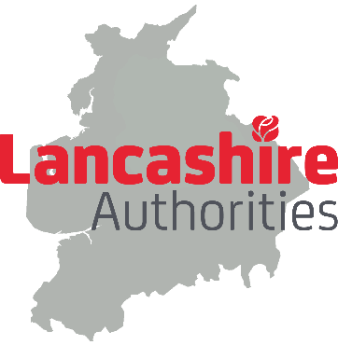

Governance

The governance structures for delivering the strategic plan priorities and accelerating that delivery through a County Deal would need be designed with two aims in mind:
- to create the best arrangements to deliver the priorities within the strategic plan and the Deal itself.
- to ensure decisions are made democratically and with all partners having an equal voice.
To this end, Leaders have agreed a set of core principles which should be applied in the establishment of any governance arrangements for joint working and delivering a County Deal. The principles set out below will form the basis of a negotiation with Government including the implications of any white paper:
- Lancashire authorities do not collectively support a Mayoral Combined Authority or local government reform
- Each authority would be represented on the decision making body by their Leader
- Each authority's current services, including statutory functions and discretionary services would not be included in any county deal arrangement without the express agreement of that authority
- The voting principle is one council, one vote, with a two thirds majority required for any proposal
- Each council will have a veto if any proposal is in their area, if their money is required or if they can reasonably demonstrate that it is reasonably likely to have a material impact on their area unless there are special circumstances to proceed (e.g. policy, legal, public safety reasons).
- Individual councils will have the right to leave the Deal and the decision making body arrangements
- It would initially be chaired by Lancashire County Council which will also act as the accountable body (under some governance models an Accountable Body may not be necessary)

Initial discussions with Leaders have started to consider a range of possible options for more formal joint working and to govern the delivery of a devolution framework and a county deal. A number of options are being explored, including joint committees, statutory boards, non-statutory boards, a local authority owned company and other informal working arrangements. This may also be largely dependent on the contents of the White Paper and any specifications it makes for the governance of County Deals.
Whatever the arrangements identified as best suited to the Lancashire area, each individual Local Authority's Full Council would need to give approval to its participation.
As the governance arrangements are developed further, a number of important issues will need to be addressed, such as managing possible conflicts of interest, providing indemnitees to members against liabilities, borrowing and funding arrangements and the detail of meeting processes. Each governance model option may require different solutions to these kinds of issues. A representative working group of officers including several Monitoring Officers has already begun work on these issues.
Resources
As progress is made, consideration will need to be given by Leaders and councils to support and resource options to manage and deliver any agreed plan and Deal. Local Authorities will need consider a fair way for each partner authority to contribute. It is also the intention to seek capacity funding from Government as part of the negotiation process for a new Deal.

